Lab 4
Database Concepts
Marin Aske
10/19/2024

Switchboard should be a two-option switchboard that leads to a report following the query of Shipment ID with Supplier Info (Name and City) with Part info, and a form showcasing the query of Job Number and Name, Shipment ID, Supplier number, Part number and Part Location. This switchboard has 2 buttons that lead to editing the form and displaying the report with a picture following the PowerPoint’s guidelines.

Switchboard Design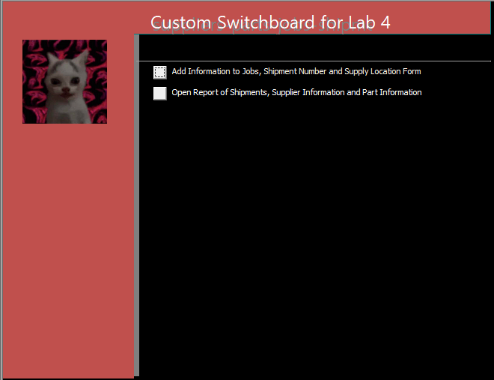

Button One Opens to this: (Edit page for the custom form)
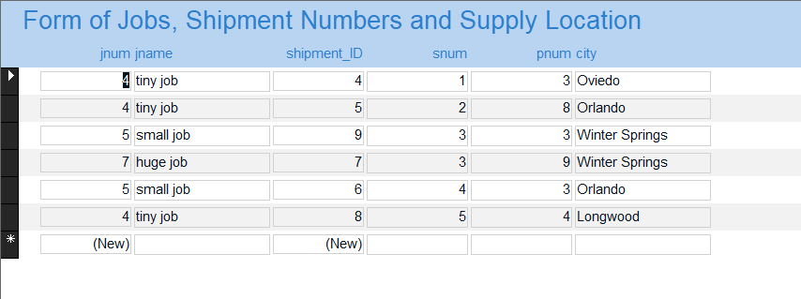

Button Two Opens to this: (Custom Report)